Hybridization in CH₄, C₂H₄, and C₂H₂

The electron configuration for carbon is 1s² 2s²2p_{x}¹2p_{y}¹2p_{z}⁰
The “ground state” orbital diagram for carbon: [He] _↑↓_ _↑_ _↑_ ___
2s 2p

Hybridization: The concept of orbital mixing

The simplest compound formed between carbon and hydrogen is methane, CH₄. Therefore, it is proposed that in CH₄ and other carbon compounds, where the carbon is singly bonded to four other atoms, covalent bonding involves the hybridization of 2s and 2p orbitals of the carbon atom.

sp³ Hybridization

_↑_ _↑_ ___
2p
_↑_ _↑_ _↑_ _↑_
E sp³
_↑↓_ Hybrid Orbitals in Carbon
2s
Unhybridized
Orbitals in Carbon

Each hybrid orbitals has one part of 2s and three parts 2p characters, hence the notation sp³ hybrid orbital. In CH₄ each sp³ hybrid orbital of carbon overlaps with the 1s-orbital of hydrogen to form a sigma C—H bonds. The orbital diagram in CH₄ may be written as:

[He] _↑↓_ _↑↓_ _↑↓_ _↑↓_ (σ-overlaps)
σ(sp³-1s)

The four sp³ orbitals and the resulting CH₄ molecule have tetrahedral shape with 109.5º bond angles. sp³ hybridizations occur in other compounds where a carbon atom is single-bonded to four other atoms, with the geometry about such carbon being tetrahedral.

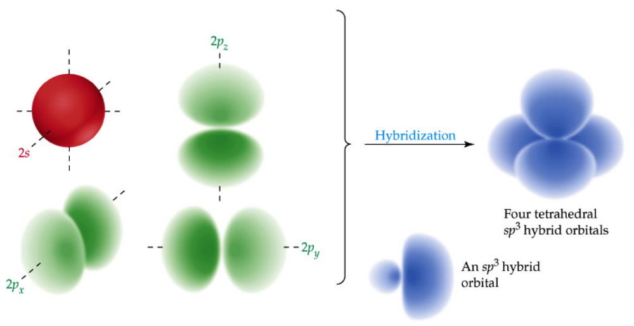
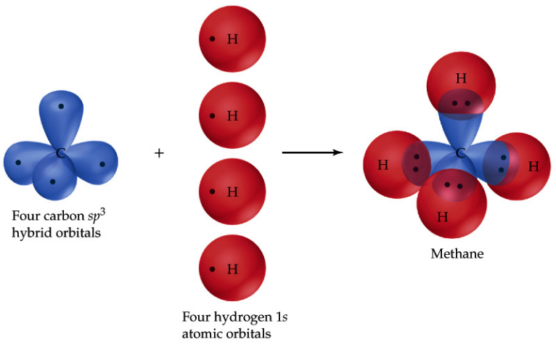

sp² Hybridization in C₂H₄

_↑_ _↑_ ___ _↑_ (unhybridized 2p-orbital)
2p 2p

_↑_ _↑_ _↑_ (hybrid sp² orbitals - singly occupied)
E sp²

_↑↓_ sp² Hybrid Orbitals
2s
Atomic Orbitals
in Carbon

In C₂H₄ molecule, one of the sp² orbitals from each carbon forms end-wise (or head-on) overlap with a sp² orbital of the second carbon; each of the other hybrid orbitals overlaps with the 1s orbital of hydrogen atom. End-wise overlap produces sigma (σ−) bonds. The unhybridized 2p orbital on each carbon side-wise overlaps with one another to form a π-bond. A carbon-carbon double bond is composed of a σ-bond and a π-bond. Molecular geometry about a particular atom is determined by the orientation of σ-bonds. Three σ-bonds about an atom assume the trigonal planar orientation.
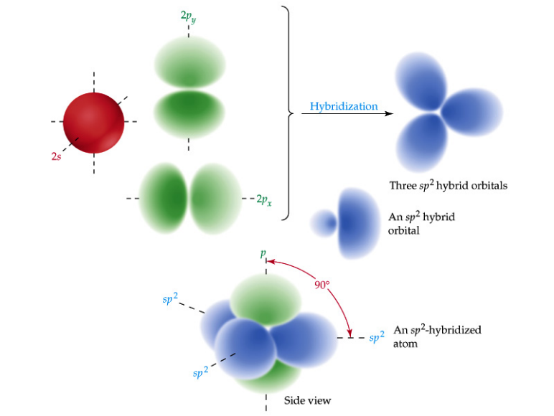
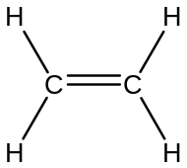
σ-bond + π-bond
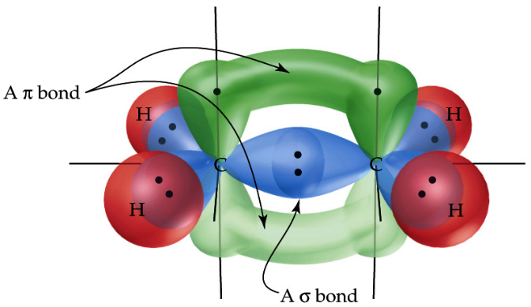

sp Hybridization in C₂H₂

2p: _↑_ _↑_ _↑_ _↑_ _↑_ (2p-orbitals, unhybridized)

_↑_ _↑_ (sp hybrid orbitals)
Hybridized
2s: _↑↓_
Unhybridized H—C≡C—H contains 1 σ- and 2 π-bonds

In C₂H₂ molecule two sp orbitals, one from each carbon, overap end-wise (head-to-head) to form a σ(C—C) bond; the other sp-orbital on each carbon overlaps with 1s-orbital of hydrogen to form a σ(C—H) bond. The unhybridized 2p-orbitals form sidewise overlaps to yield two π(C—C) bonds. Thus, carbon-carbon triple bonds in C₂H₂ consist of one σ- and two π−bonds. C₂H₂ molecule has a linear shape as a consequenced of sp hybridization on the carbons. Other examples where sp-hybridization occurs are in N₂, CO₂, and H₂C=C=CH₂ (called ketene)



